Long Term Overview: The Reading Journey for Year 4 2021-2022 Non-Fiction Fiction Poetry Author focus
Autumn 1 | Autumn 2 | Spring 1 | Spring 2 | Summer 1 | Summer 2
Reading Journey 1 | Reading Journey 1 | Reading Journey 1 | Reading Journey 1 | Reading Journey 1 | Reading Journey 1
Topic: Rotten Romans | Topic: Drip, Drip, Drop! | Topic: Here, There and Everywhere! | Topic: Traders and Raiders! | Topic: Sand V Land | Topic: Choo Choo!
Roald Dahl Day:  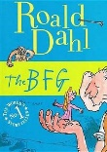  Narrative –VIPERS  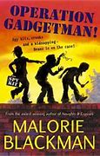  Narrative – settings, feelings, inference  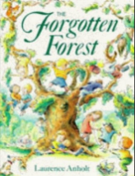  Non-Fiction: The Romans  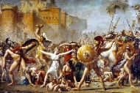  Poetry: retrieve and visualise information in the text.  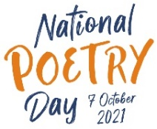 | Narrative –VIPERS  Narrative – character’s feelings, summarising  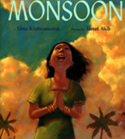  Narrative –VIPERS  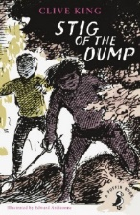  Non-Fiction: The Rhythm of the Rain  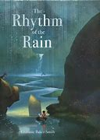 | Narrative – The Great Kapok Tree  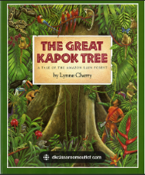  Biography:  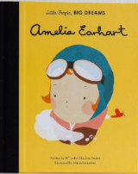  Narrative –VIPERS  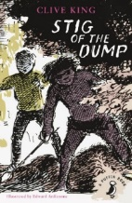  Narrative –VIPERS  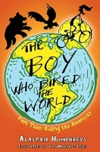  Non-Fiction: World | Narrative –VIPERS  Non-Fiction: Vikings  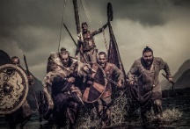  Non-Fiction: Dragons  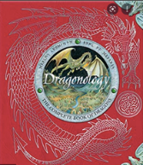 | Narrative –VIPERS  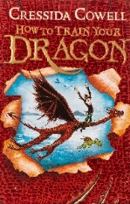  Non-Fiction: Legends of the Deep  Poetry: Dracula  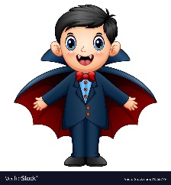 | Non-Fiction: The Industrial Revolution  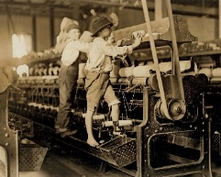  Narrative –VIPERS  Non-Fiction: Famous Scientists

